METRO TICKETING SYSTEM
2025079 AHMED AMAN ULLAH KHAN
2025421 MOHID SALMAN
2025806 SYED ALI ABBAS ABIDI
This project is a Metro Ticketing System created using only the basic concepts of C++ in CS101. This allows the user to view available metro stations in Karachi, select origin and destination, calculate ticket price based on distance, purchase ticket, create a metro card, log in using card number and PIN and receive a discounted fare when logged in.
We chose this project because ticketing systems are practical and easy to understand. They are used daily in public transportation, and implementing one helps us apply conditional statements, loops, user defined functions, file handling and arrays. This project allowed us to build a real life system using only beginner level C++ concepts. The purpose of this project is to simulate a simple metro ticketing system, allow users to create a metro card and log in, provide discounted tickets to logged in users and it also stores card details and transactions in files.
People who travel often need a fast and simple way to purchase metro tickets. The manual system is slow and does not offer discounts. There is also no record of previous transactions. To solve this problem, we built a simple digital ticketing system which calculates the fare automatically, stores card details, allows quick log in and discount features, and saves purchase history.
We developed a console based program that shows a list of stations stored in a simple array, calculates ticket price using the absolute difference in station numbers, stores metro card in a file, card_num.dat, allows login using card number and PIN, stores ticket purchases in transaction.dat file, gives a 15% discount if the user is logged in, and uses user defined functions to make the code modular.

List of Features:
- Display stations:
Shows the list of stations, this outputs the stations names. Its function is called show_stations()
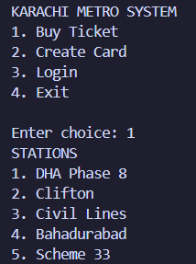

- Create metro card:
Generate new card number and PIN, this outputs card number and PIN which is also is saved to a file, card_num.dat. Its function is divided into 2 parts, one is generate_card_num() and second is create_card().
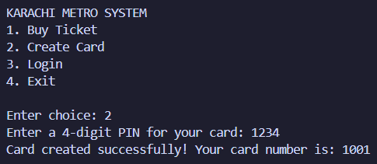

- Login:
Authenticate card number and PIN, it takes card number and PIN as input, this outputs if login is successful or unsuccessful. Its function is login(int &card).
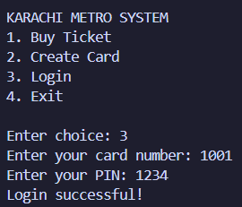

- Buy Ticket:
Selects origin and destination and computes fare. It takes station number as input, this outputs price and then ticket is saved to a file, transaction.dat. Its function is called buy_ticket(bool is_logged_in, int card_num).
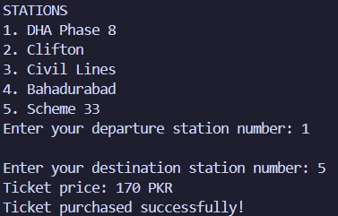
This project successfully demonstrates how C++ concepts can be used to build a functional metro ticketing system. This system provides a simple interface, realistic ticket price calculation, card storage, login authentication, discounted fares for cardholders and purchase history.

